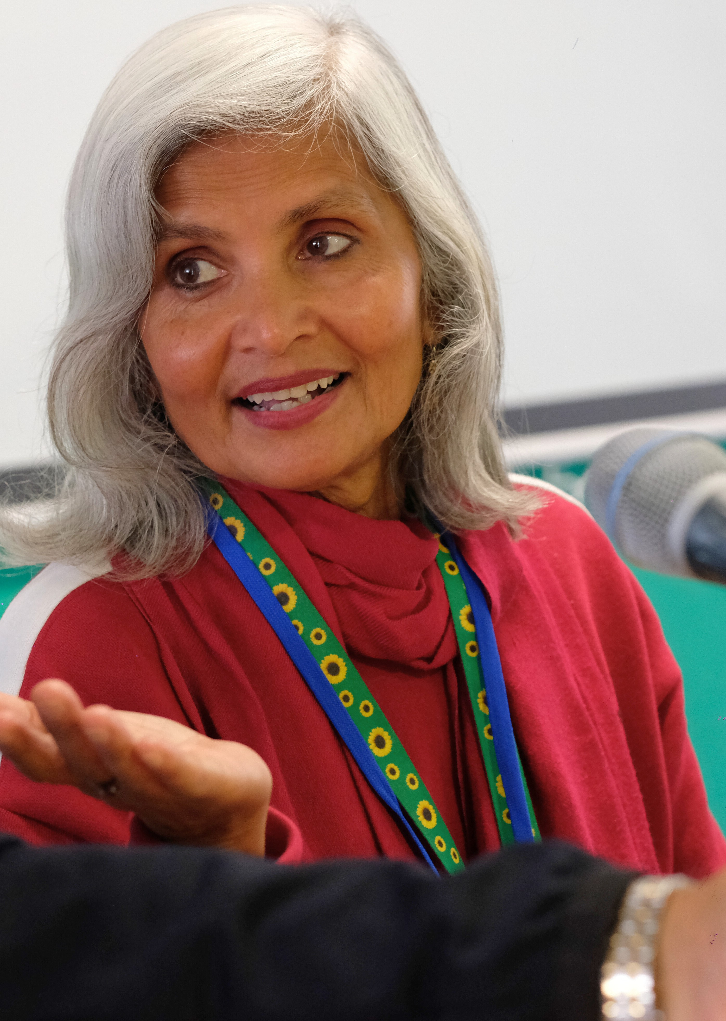



Service Development Lead Job Pack

Job Details
Job Title: Location:

Team: Responsible to: Contract: Hours
Salary:

Service Development Lead
Headway East London, 238-240 Kingsland Road, London E2 8AX Hybrid working option, however at least 3 days will be in person based at Headway East London.
Services Clinical Lead
Fixed term contract until May 2026 28 hours per week
£29,409.70 (pro rata £23,527.76)


About Us
Registered Charity No: 1083910.
Headway East London (www.headwayeastlondon.org) is a charity supporting people living with brain injury. Working across 13 London boroughs we offer specialist support and services for survivors and their families. We offer therapies, advocacy, family support and community support work alongside our day service: a community venue where people can make the most of their abilities and interests.
We also promote awareness and understanding of brain injury by providing information to the public, and offering training to university students, professionals and businesses.
Our vision is to build a community where people with brain injury are valued, respected and able to fulfil their potential.


About the Role
Registered Charity No: 1083910.
Working closely with the Therapy Manager, Clinical Lead and Director of Services, you will deliver the marketing of a programme of member-led training for external organisations and other services at Headway East London.

Working directly with our members, you will deliver projects of a high standard which are co-produced and reflect the diversity of our community.

You will take a lead on developing and delivering the marketing material.
You will collaborate with our members, staff and partners to advance our aims to educate professionals in the public sector, whilst exploring ways to generate income for the organisation through this source.

Principal Duties and Responsibilities
- Identify opportunities to engage external stakeholders with the member-led training project of delivering external training to professionals within the public sector.
- Work directly with Headway members to develop and deliver this project, embedding this work within the organisation’s co-production strategy.
- Support members to participate in these events in collaboration with other teams, by providing direct practical assistance to members.


- Identify and seek out new external opportunities which support the development of our therapy service, ensuring that opportunities are quickly acted on.
- Explore potential income generation for Headway East London.

- Lead on the design work associated with some of this work (e.g., mock-ups, early design concepts, marketing collateral) and present this externally and through social media channels.
- Assist with fundraising activity related to the ongoing reporting and development of this project.
- Lead on the marketing and promotion of this project alongside other services.

- Maintain accurate records and filing systems and ensure effective documentation of project deliverables.
- Work in close collaboration with Headway East London teams to stay informed of new members, interests and needs.

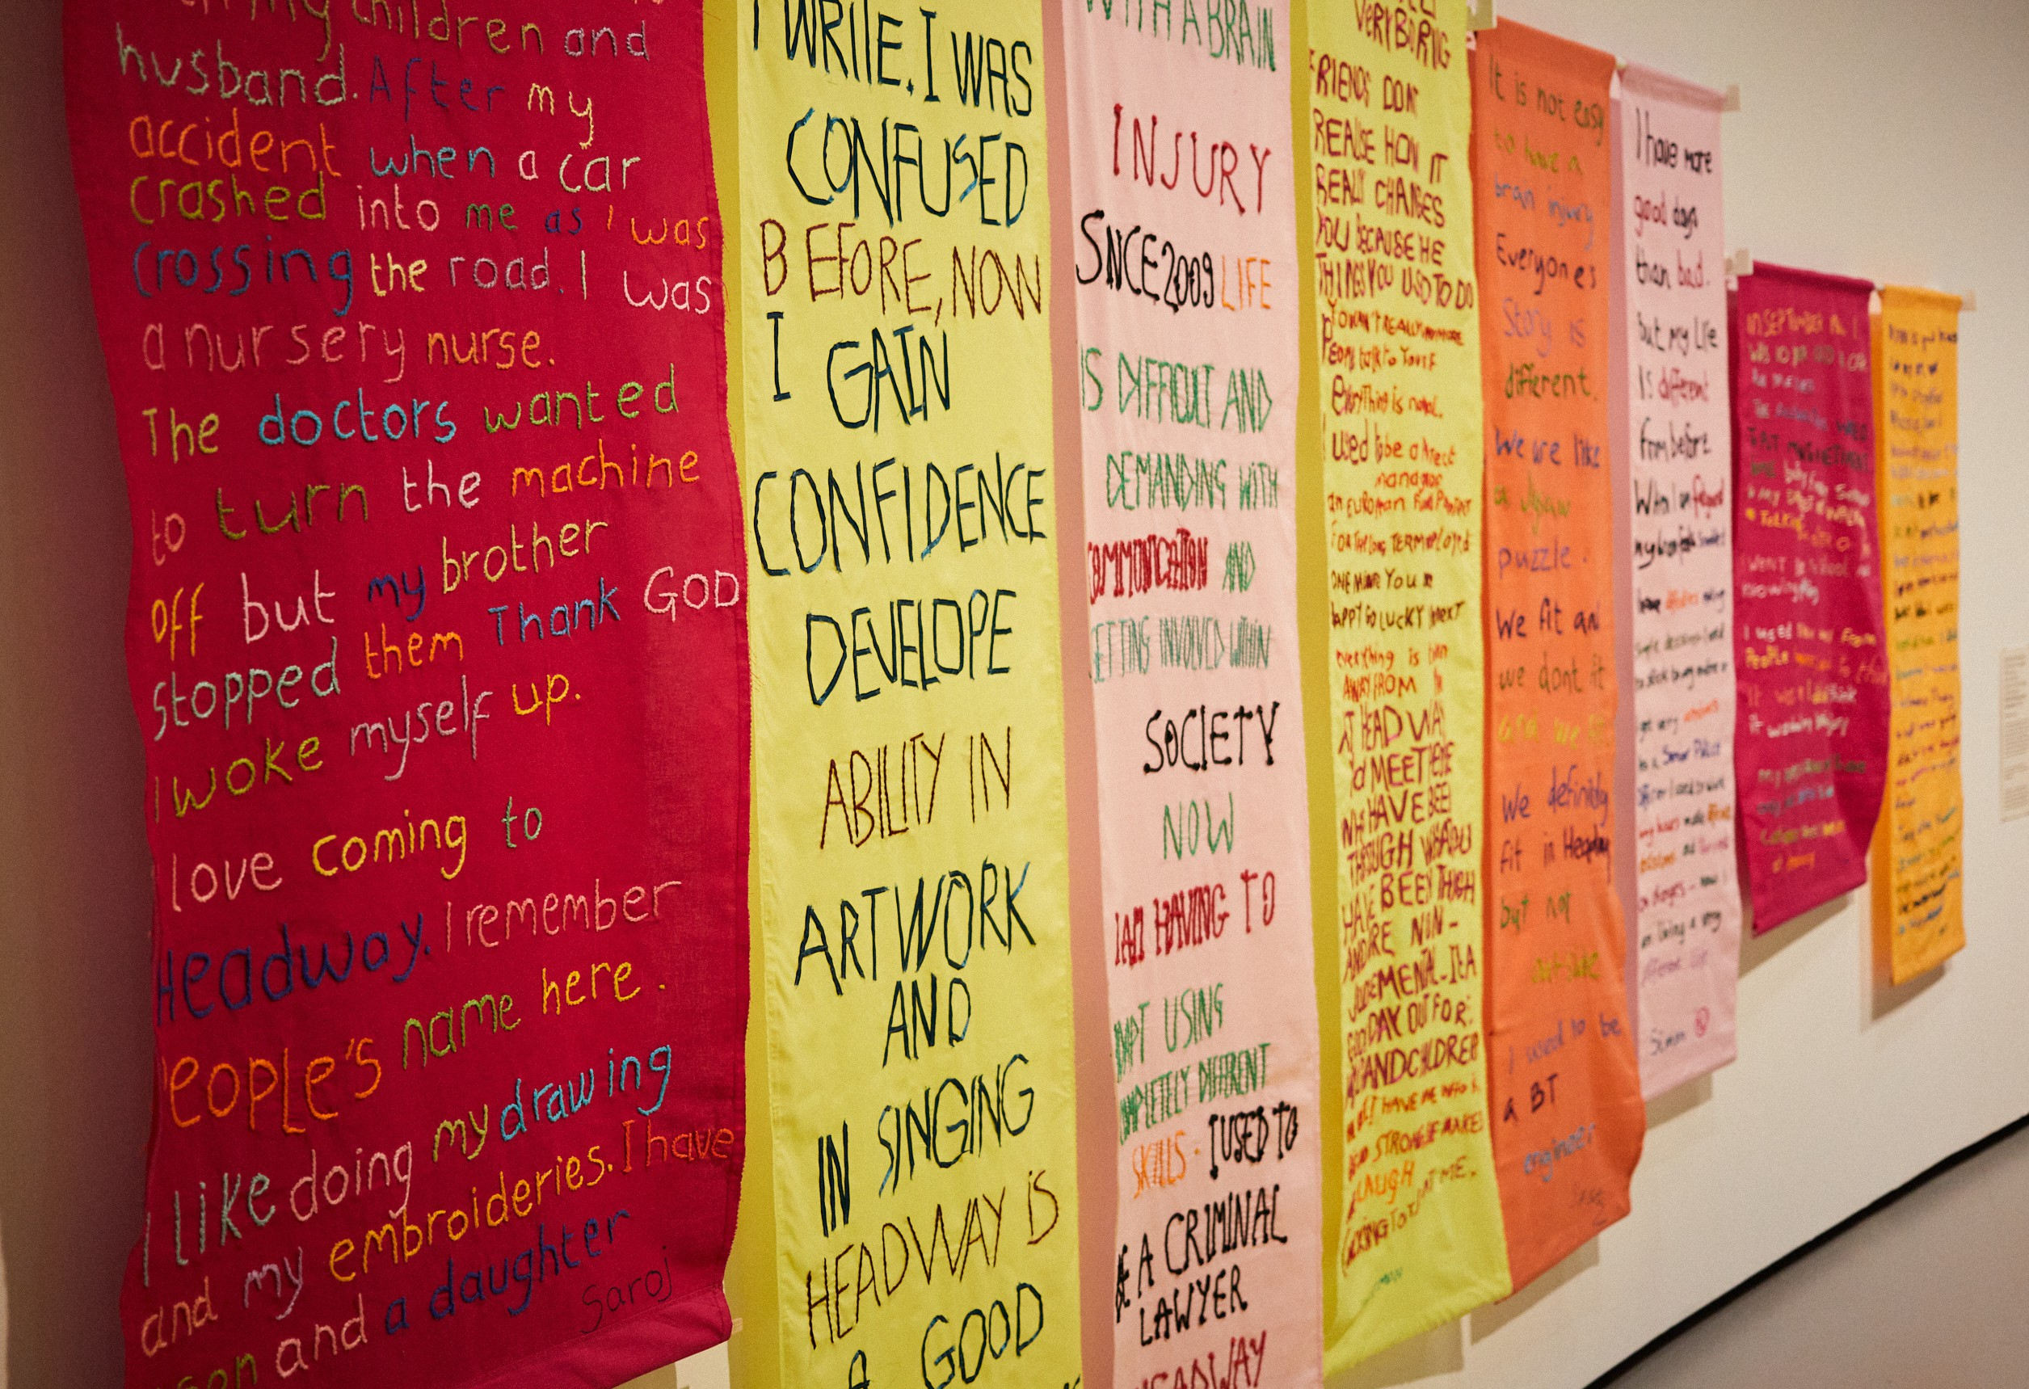
Key Relationships - Internal and External
Registered Charity No: 1083910.
Internal: Therapy Manager, Clinical Lead, Director of Operations, Peer Training Lead, Public Engagement and Communication Manager, Director of Fundraising, Service Managers and members of Headway East London.
External: Professionals from the public sector supporting people with acquired brain injuries.
Health & Safety/GDPR
Comply with safe working practices as outlined in Headway East London policies and take reasonable care for your own health and safety and that of others who may be affected by acts or omissions at work.
Report any accidents, incidents or near misses as soon as reasonably practicable.
Comply with GDPR guidance as outlined in Headway East London policy and report any breaches as soon as reasonably practicable.


General
Registered Charity No: 1083910.
Be aware of and adhere to Headway East London policies at all times. Take part in progress/performance reviews throughout the year.
Cooperate with other departments to achieve good outcomes for our members.
Attend training courses and complete online training modules as required to meet the requirements of the post.
Take responsibility for own personal development, seeking out opportunities to learn new skills.
Undertake any other duties as requested by management which are reasonably deemed to be within the scope of the role or necessary for the smooth running of the organisation.

Other
Apply the Headway East London values and behaviours to every aspect of the role at all times.
Protect and enhance the interests and reputation of Headway East London internally and externally.
Commit to the organisational principles of: coproduction
equity, diversity and inclusion
sustainability

Person Specification
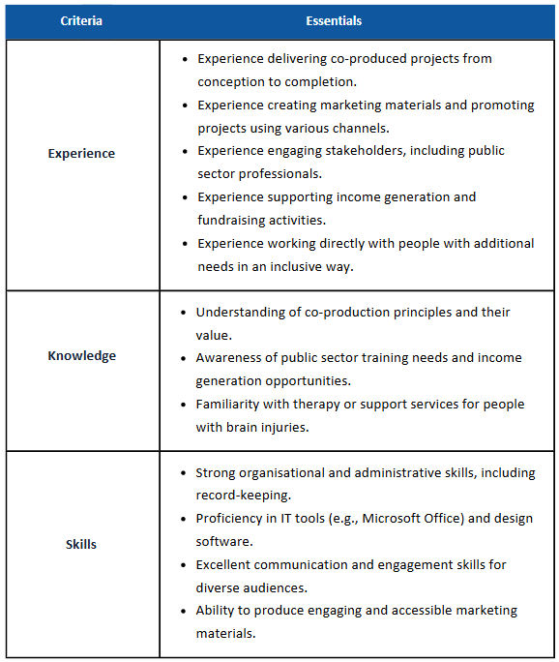

Registered Charity No: 1083910.

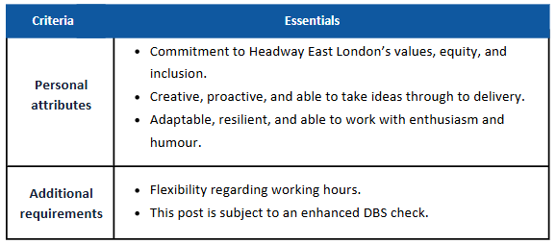
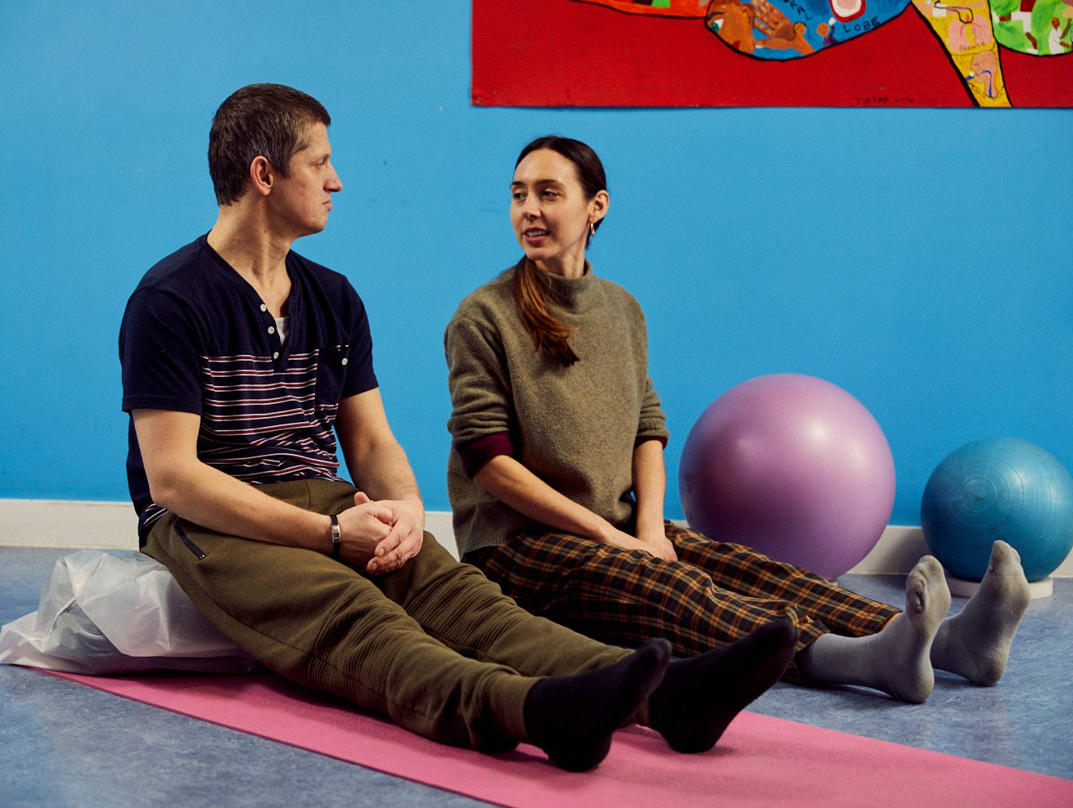

The above job description is not exhaustive but an indication of the duties the post holder may undertake and will be subject to review.

Registered Charity No: 1083910.


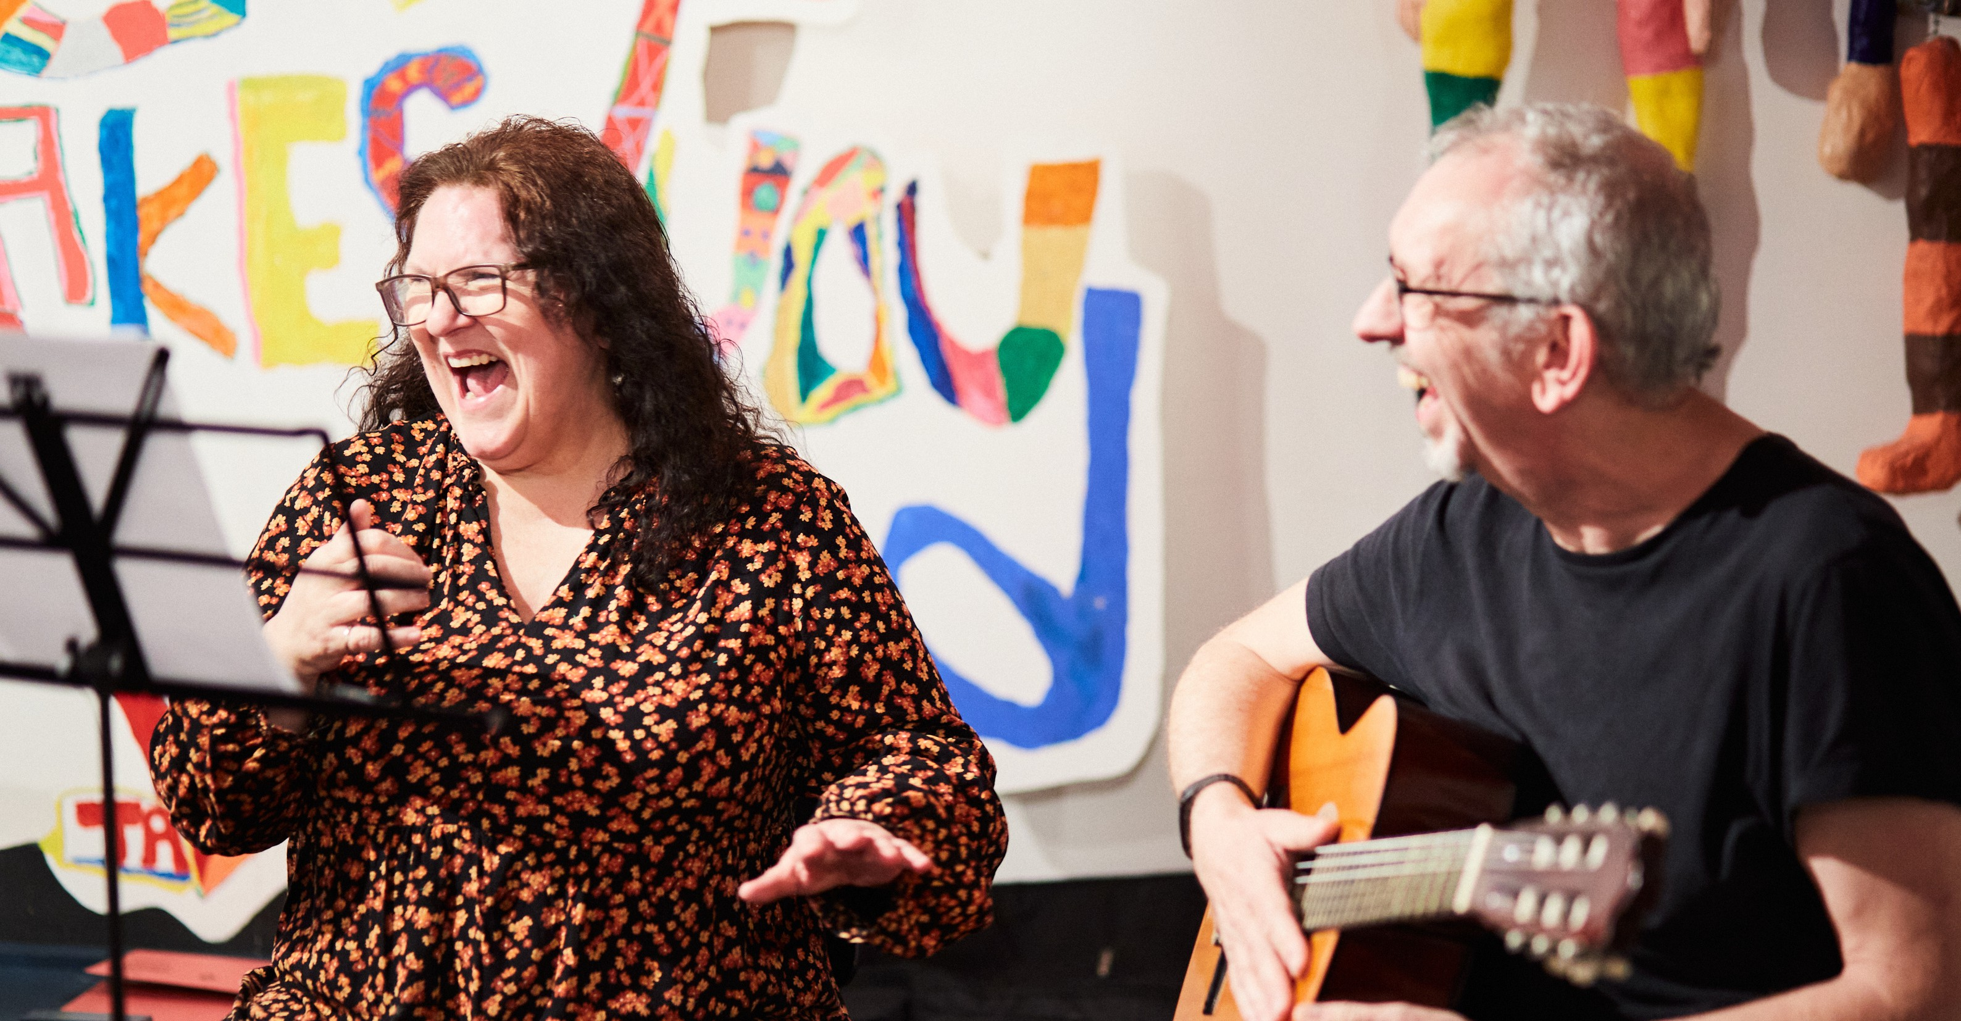


Service Development Lead

To apply
The deadline to apply is 9:00 am, Wednesday 15 January 2025.
Interview will be held w/c Monday 27 January.
Please send your Application Form and voluntary Equal Opportunities Monitoring Form
to recruitment@headwayeastlondon.org

For further information about the role and Headway East London, please contact the Clinical Lead Claire Farrington-Douglas at
claire.farrington-douglas@headwayeastlondon.org or call on 020 7749 7790. No agencies please.

Headway East London is an Equal Opportunities Employer and we are committed to ensuring that all staff are motivated, skilled and rewarded by their work. We welcome applicants regardless of race, religion or belief, colour, national origin, sex, sexual orientation, disability, age and other protected status as required by law. We promote and protect human rights; they are the foundation of what we do.
We want to be an inclusive place where a diverse mix of talented people want to come and contribute their unique strengths and perspectives. We are focused on equality and believe that all the fascinating characteristics that make us different, make us more able to deliver our life-changing work with passion and creativity.

Registered Charity No: 1083910.

