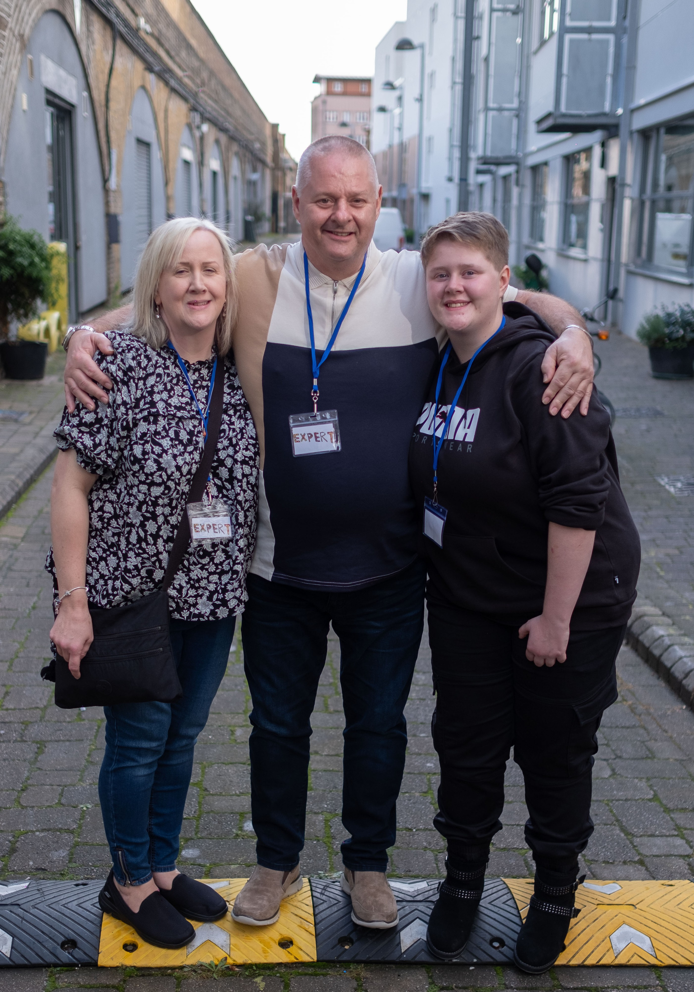

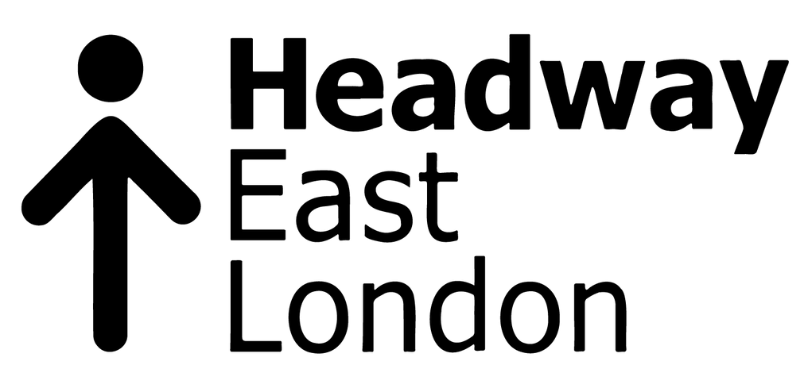

Caseworker Job Pack

Job Details
Job Title: Location: Team: Responsible to: Contract: Hours:
Salary:

Caseworker
Headway East London, 238-240 Kingsland Road, London E2 8AX Casework Service
Casework Service Manager Permanent
35 hours per week (full time)
£28,235.07

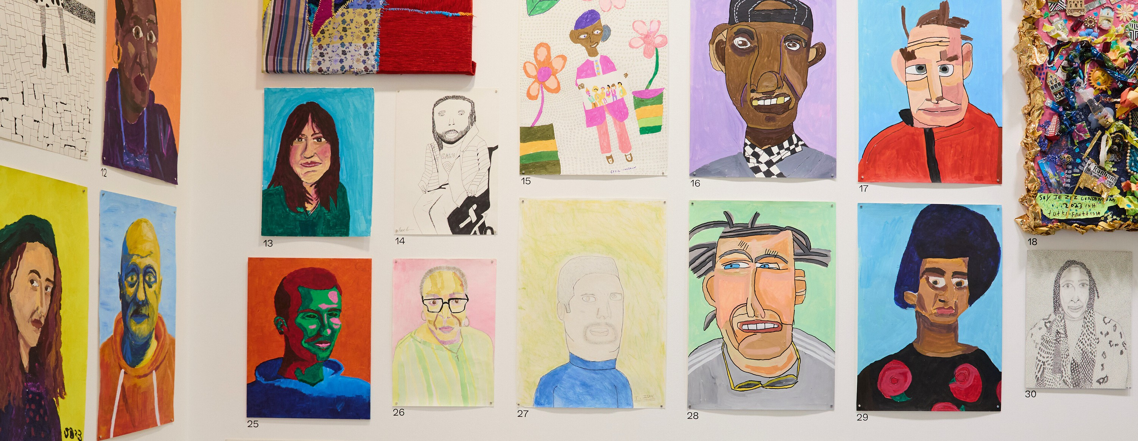
Registered Charity No: 1083910.

About Us
Headway East London (www.headwayeastlondon.org) is a charity supporting people living with brain injury. Working across 13 London boroughs we offer specialist support and services for survivors and their families. We offer therapies, advocacy, family support and community support work alongside our day service: a community venue where people can make the most of their abilities and interests.
We also promote awareness and understanding of brain injury by providing information to the public, and offering training to university students, professionals and businesses.
Our vision is to build a community where people with brain injury are valued, respected and able to fulfil their potential.

About the Role
The Casework Service main aim is to ensure that survivors and families have access to the benefits and support they are entitled to. This means working directly with local authorities and statutory organisations, or signposting to relevant partners.
Through our Better Together project at the Royal London Hospital and Queens Hospital Romford we offer early intervention inside the hospital, so that brain injury survivors and their family can access information, emotional support and assistance.
As a Caseworker you will be working closely with people with acquired brain injuries through our Better Together project, in support groups and in one-to-one casework appointments. You will be providing advice, advocacy, support and signposting.

Principal Duties and Responsibilities
- Support people with lived experience of brain injury, families and carers through Casework projects and support groups. This could be in accessing the right benefits, housing issues or gaining the right care moving forward.
- Take part in our Better Together project at the Royal London Hospital and Queens Hospital Romford. We visit each hospital weekly.
- Make appropriate referrals to Headway East London services, and other relevant professionals/services.
- Contribute to events for professionals engaged in working with people with lived experience of brain injury, highlighting the needs of our members and the work we do.
- Help run our Saturday Social (once a month) which provides a safe setting for members to be part of a community space.
- Monitor and document on all work undertaken and update our database constantly and efficiently.

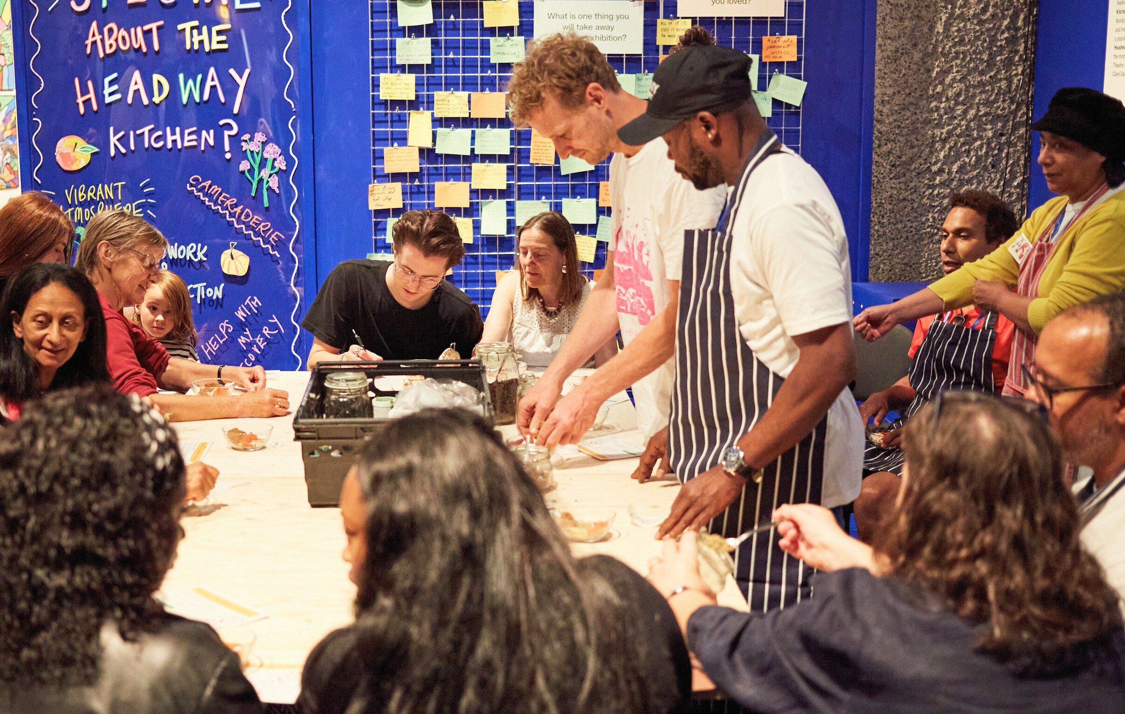
Key Relationships - Internal and External
Registered Charity No: 1083910.
Operational Staff – Headway East London Members/clients families and carers
External Partners including health and social care providers, litigation professionals and case managers, educational settings and students

Health & Safety/GDPR
Comply with safe working practices as outlined in Headway East London policies and take reasonable care of your own health and safety and that of others who may be affected by acts or omissions at work.
Report any accidents, incidents or near misses as soon as reasonably practicable.
Comply with GDPR guidance as outlined in Headway East London policy and report any breaches as soon as reasonably practicable.

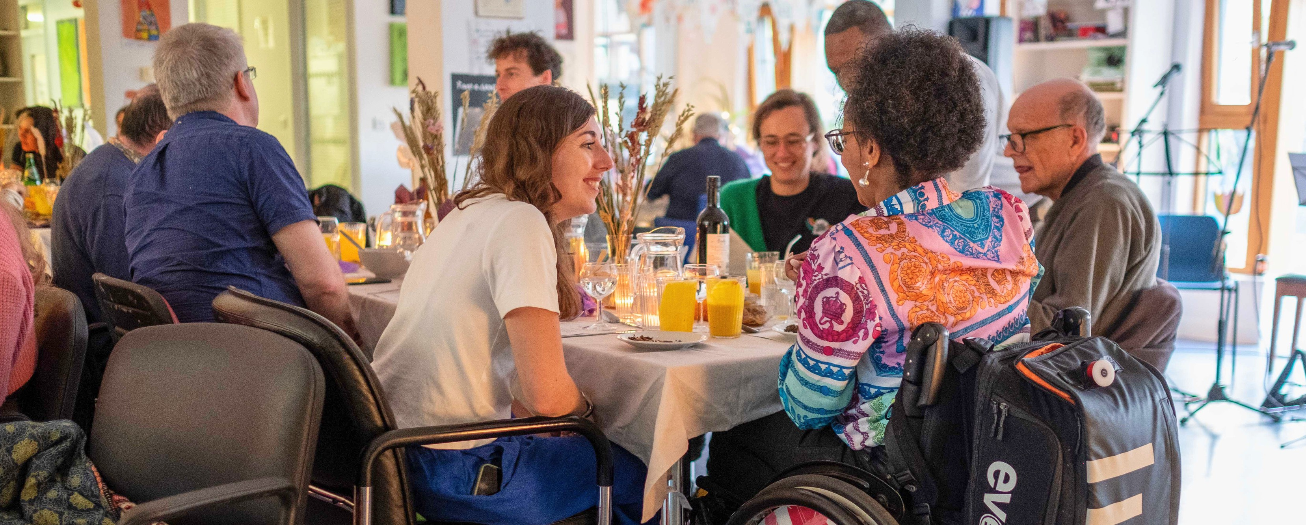
General
Registered Charity No: 1083910.
Be aware of and adhere to Headway East London policies at all times. Take part in progress/performance reviews throughout the year.
Cooperate with other departments to achieve good outcomes for our members.
Attend training courses and complete online training modules as required to meet the requirements of the post.
Take responsibility for own personal development, seeking out opportunities to learn new skills.
Undertake any other duties as requested by management which are reasonably deemed to be within the scope of the role or necessary for the smooth running of the organisation.

Other
Apply the Headway East London values and behaviours to every aspect of the role at all times.
Protect and enhance the interests and reputation of Headway East London internally and externally.
Commit to the organisational principles of: coproduction
equity, diversity and inclusion
sustainability

Person Specification
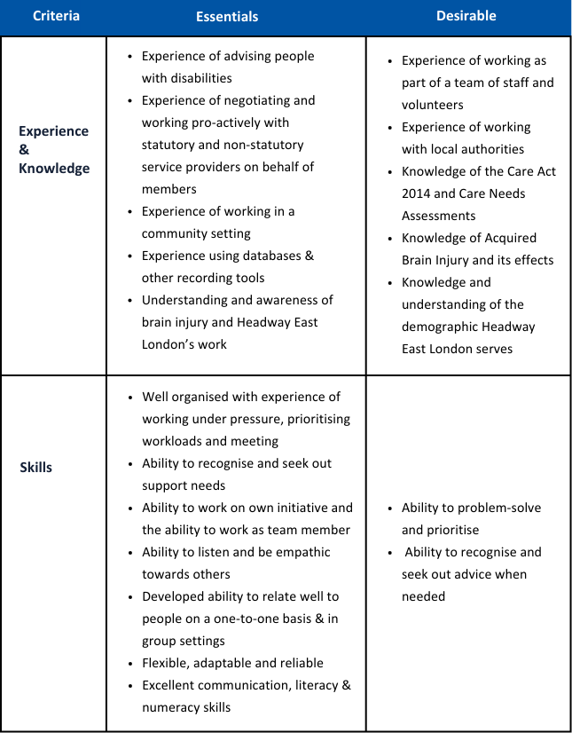

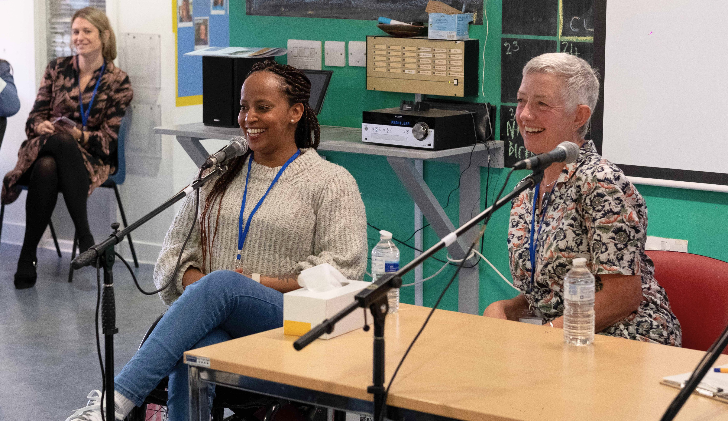
Registered Charity No: 1083910.
Criteria | Essentials | Desirable
 | Commitment to the values, | Committed and enthusiastic Commitment to continuous personal development
Personal attributes | behaviours, and principles of the organisation
 | Demonstrable commitment to
 | working in ways which promote
 | equity, diversity, and inclusion

This job description outlines the current main responsibilities of the post; however, the duties of the post may change and develop over time and the job description may be amended in consultation with the post holder.

N.B that the successful candidate, should they be accessing services provided by Headway East London, will be required to step down as a member of these services, including Day service, CSWS and Saturday social.
They will only join the support groups as co-facilitator.


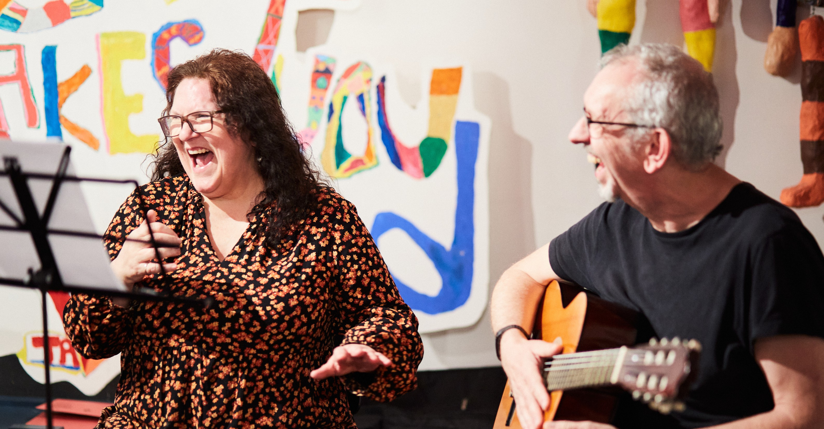


Caseworker

To apply
The deadline to apply is 9:00 am, Monday 6 January 2025.
Please send your Application Form and voluntary Equal Opportunities Monitoring Form to
recruitment@headwayeastlondon.org.

For further information about the role and Headway East London, please contact the Casework Service Manager Paul McKay email at paul.mckay@ headwayeastlondon.org or call on 020 7749 7790.
No agencies please.

Headway East London is an Equal Opportunities Employer and we are committed to ensuring that all staff are motivated, skilled and rewarded by their work. We welcome applicants regardless of race, religion or belief, colour, national origin, sex, sexual orientation, disability, age and other protected status as required by law. We promote and protect human rights; they are the foundation of what we do.
We want to be an inclusive place where a diverse mix of talented people want to come and contribute their unique strengths and perspectives. We are focused on equality and believe that all the fascinating characteristics that make us different, make us more able to deliver our life-changing work with passion and creativity.

Registered Charity No: 1083910.

