Finance and Administration

Assistant

Application Pack

Job Details

Job Title: Location: Team: Responsible to: Contract: Hours:
Salary:
Finance and Administration Assistant
Headway East London, 238-240 Kingsland Road, London E2 8AX Finance
Director of Finance Permanent contract
30 hours/week, fully worked in the Headway office
£24,250 pro rata (£20,785.71)

Registered Charity No: 1083910.

About Us
Headway East London (www.headwayeastlondon.org) is a charity supporting people affected by brain injury. Working across 13 London boroughs we offer specialist support and services for survivors and their family. We offer therapies, advocacy, family support and community support work alongside our day service: a community venue where people can make the most of their abilities and interests.
We also promote awareness and understanding of brain injury by providing information to the public, and offering training to university students, professionals and businesses.
Our vision is to build a community where people with brain injury are valued, respected and able to fulfil their potential.

About the Role
The Finance & Administration Assistant is a newly created role that will provide various parts of the organisation with administrative support, as well as some receptionist duties. This dynamic role will sit within the Finance team and report to the Director of Finance, however it will directly support the areas of Administration, Finance, Fundraising, and three different Service Delivery functions.

Principal Duties and Responsibilities

Administrative tasks
- Manage external communications through post, telephone and email, ensuring information is redirected to the relevant person to be dealt with efficiently and effectively.
- Support service/department managers with necessary purchasing.
- Keep up to date record of monthly invoicing information for services and liaise between the Senior Finance Officer and the Service Managers to ensure this system is running efficiently and effectively.

Finance related tasks
- Manage Petty Cash transactions on site, ensuring accurate and up to date records are kept at all times, and perform the bank runs.
- Collect and check monthly debit card and credit card reports with all necessary Purchase Invoices and PO’s from the card holders.
- Assist the Finance Officer in processing expenditure: checking Purchase Invoices against PO’s, ensuring that all authorisations are in place, and posting expenditure on the QuickBooks database.
- Assist the Senior Finance Officer in sending out statements to overdue Debtors from QuickBooks.

Fundraising related tasks
- Process donation payments received via cheque, cash or PayPal and similar platforms onto the Beacon database.
- Assist the Fundraising Manager in keeping the Beacon database up to date with donations/grants received, gift aid eligibility and forms, and grant contracts.
- Instigate periodic thank-you letters to donors.

Registered Charity No: 1083910.

Key Relationships - Internal and External

Finance Team, Admin Team Managers across departments Staff at Headway
Suppliers, debtors, donors and members of the public

Health & Safety/GDPR
Comply with safe working practices as outlined in Headway East London policies and take reasonable care for your own health and safety and that of others who may be affected by acts or omissions at work.
Report any accidents, incidents or near misses as soon as reasonably practicable. Comply with GDPR guidance as outlined in Headway East London policy and report any breaches as soon as reasonably practicable.

Registered Charity No: 1083910.

General

Be aware of and adhere to Headway East London policies at all times. Take part in progress/performance reviews throughout the year.
Cooperate with other departments to achieve good outcomes for our members. Attend training courses and complete online training modules as required to meet the requirements of the post.
Take responsibility for own personal development, seeking out opportunities to learn new skills.
Undertake any other duties as requested by management which are reasonably deemed to be within the scope of the role or necessary for the smooth running of the organisation.

Other
Apply the Headway East London values and behaviours to every aspect of the role at all times.
Protect and enhance the interests and reputation of Headway East London internally and externally.
Commit to the organisational principles of: coproduction
equity, diversity and inclusion
sustainability

Person Specification

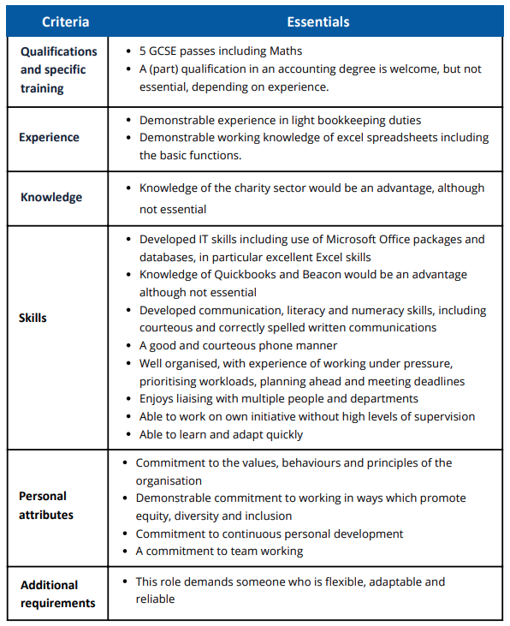

Job Description and Person Specification Agreement:
the above job description is not exhaustive but an indication of the duties the post holder may undertake and will be subject to review.

Registered Charity No: 1083910.

Finance and Administration Assistant

To apply

Please send your Application Form and voluntary Equal Opportunities Monitoring Form to

recruitment@headwayeastlondon.org.

The deadline to apply is Monday 22 July, 9am.

If you would like further information about the role and Headway East London, please contact the Director of Finance Willa Geertsema at willa.geertsema@headwayeastlondon.org or call 020 7749 7790.

Headway East London is an Equal Opportunities Employer and we are committed to ensuring that all staff are motivated, skilled and rewarded by their work. We welcome applicants regardless of race, religion or belief, colour, national origin, sex, sexual orientation, disability, age and other protected status as required by law.
We promote and protect human rights; they are the foundation of what we do.
We want to be an inclusive place where a diverse mix of talented people want to come and contribute their unique strengths and perspectives. We are focused on equality and believe that all the fascinating characteristics that make us different, make us more able to deliver our life-changing work with passion and creativity.

Registered Charity No: 1083910.

