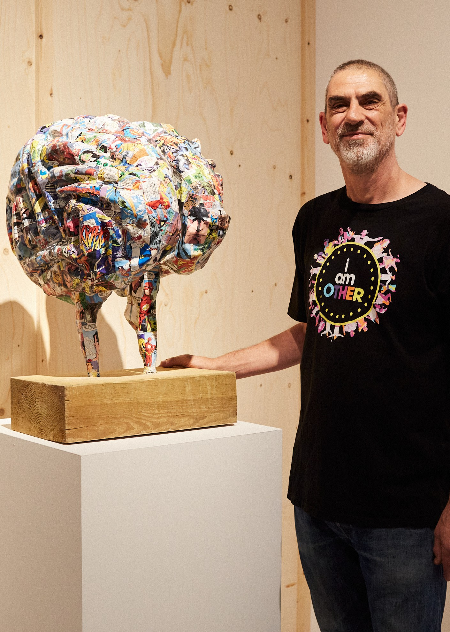

Associate Psychotherapist / Counselling Psychologist Application Pack

Job Details

Job Title: Location:

Starting Salary: Contract: Team: Responsible to:
Associate Psychotherapist / Counselling Psychologist
Headway East London, 238-240 Kingsland Road, London E2 8AX Forest Primary Care Centre, 308A Hertford Rd, London N9 7HD Online
£70/hour
Self-employed Associate Therapy
Therapy Service Manager

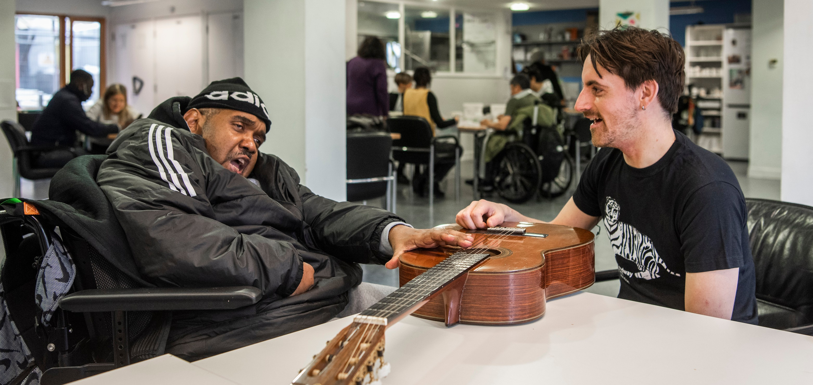
Registered Charity No: 1083910.

About Us
Headway East London (www.headwayeastlondon.org) is a charity supporting people living with brain injury. Working across 13 London boroughs we offer specialist support and services for survivors and their families. We offer therapies, advocacy, family support and community support work alongside our day service: a community venue where people can make the most of their abilities and interests.
We also promote awareness and understanding of brain injury by providing information to the public, and offering training to university students, professionals and businesses.
Our vision is to build a community where people with brain injury are valued, respected and able to fulfil their potential.

About the Role
As Associate Psychotherapist / Counselling Psychologist, you will provide psychotherapy assessments and treatment for people with acquired brain injury (ABI), and in some instances their family members, who have been referred to the Headway East London Private Therapy Service and the Enfield Brain Injury Service (Enfield).
You will join a dynamic team of professionals bringing expertise across a range of therapies to give each person living with brain injury what they need in the best way for them. Our unique interdisciplinary approach means that the team works alongside our service staff to identify the best therapeutic intervention.

Principal Duties and Responsibilities
Provide one-to-one counselling to private and Enfield clients with ABI on combinations of issues including: trauma and life-changing events; depression and anxiety; adjusting to acquired disability; sexual health; relationship and marriage problems; drug and alcohol dependency; anger management, aggressive and criminal behaviour.
Ensuring that each brain injury survivor is supported according to their varying needs, including cognitive impairment or neuropsychiatric problems associated with ABI; evaluate progress and adapt therapy as
necessary.
Support, advise and provide brain injury education for clients and/or carers as appropriate, as well as provide advice to educational establishments, workplaces and other community resources to promote clients’ successful (re) engagement in education / work / leisure in the community.
Maintain accurate and up to date documentation for all of caseloads and provide written reports for external professionals such as GPs and case managers.
Maintain up to date knowledge of clinical and professional development in the field of neurological
psychotherapy, including selecting and requesting appropriate resources for the Psychological Therapy service while setting a high personal standard of practice incorporating this appropriately into clinical practice.
Liaise regularly with the team to provide updates on issues relevant to member engagement in other aspects of their rehabilitation as part of the multidisciplinary team.

Registered Charity No: 1083910.

Key Relationships - Internal and External
Operational Staff – Headway East London Members/clients, their families and carers
External Partners including health and social care providers, litigation professionals and case managers, educational settings and students

Health & Safety/GDPR
Comply with safe working practices as outlined in Headway East London policies and take reasonable care of your own health and safety and that of others who may be affected by acts or omissions at work.
Report any accidents, incidents or near misses as soon as reasonably practicable.
Comply with GDPR (General Data Protection Regulation) guidance as outlined in Headway East London policy and report any breaches as soon as reasonably practicable.

General
Be aware of and adhere to Headway East London policies.
Cooperate with other departments to achieve good outcomes for our members.
Take responsibility for own personal development and supervision, seeking out opportunities to learn new skills.

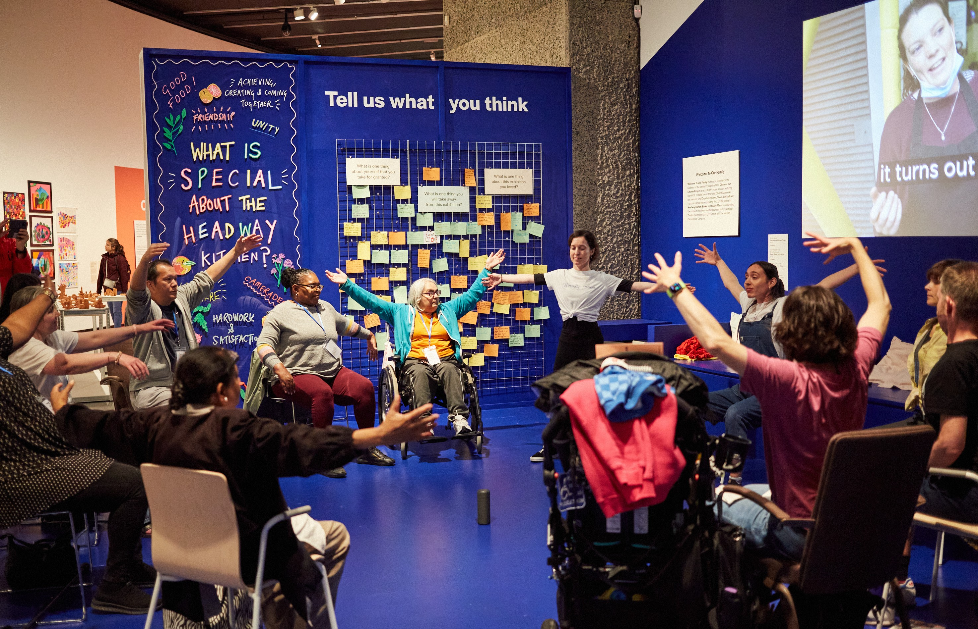
Registered Charity No: 1083910.

Other
Apply the Headway East London values and behaviours to every aspect of the role at all times. Protect and enhance the interests and reputation of Headway East London internally and externally. Commit to the organisational principles of:
coproduction
equity, diversity and inclusion sustainability

How you will work
In a way which promotes diversity, equality of opportunity and anti-discriminatory practice in line with Headway’s Equal Opportunities Policy.
Operate at all times in a way that is consistent with Headway East London’s legal responsibilities including data protection, health and safety legislation and guidance, seeking specialist guidance where appropriate.
Work in accordance with Headway East London’s aims, objectives, policies and procedures and to promote a positive image of the organisation and its members.
Undertake such other duties as may reasonably be required, commensurate with the level of the post.

Person Specification

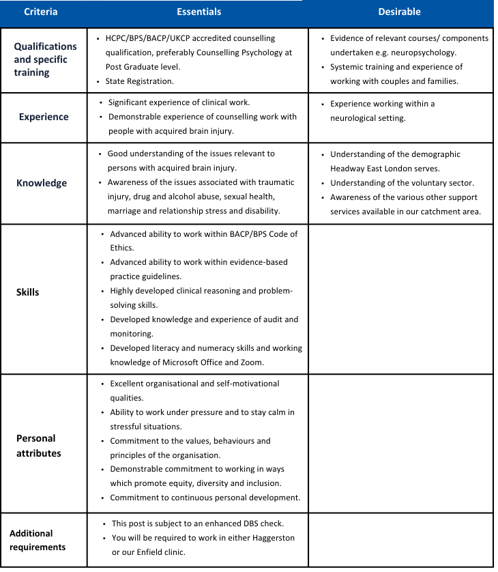
The above job description and person specification are not exhaustive but an indication of the duties the post holder may undertake and will be subject to review.

To apply

Applications will close when we have received a sufficient number of applicants. Please send your Application Form and voluntary Equal Opportunities Monitoring Form to recruitment@headwayeastlondon.org.
For further information about the role and Headway East London, please contact Nora Brennan via email at
nora.brennan@headwayeastlondon.org or call on 020 7749 7790. No agencies please.

Headway East London is an Equal Opportunities Employer and we are committed to ensuring that all staff are motivated, skilled and rewarded by their work. We welcome applicants regardless of race, religion or belief, colour,
national origin, sex, sexual orientation, disability, age and other protected status as required by law. We promote and protect human rights; they are the foundation of what we do.
We want to be an inclusive place where a diverse mix of talented people want to come and contribute their unique
strengths and perspectives. We are focused on equality and believe that all the fascinating characteristics that make us different, make us more able to deliver our life-changing work with passion and creativity.

