Casework Peer Support Worker
Job Details
Job Title: Casework Peer Support Worker
Location: Headway East London, 238-240 Kingsland Road, London E2 8AX
Royal London Hospital, Whitechapel Rd, London E1 1FR
Queen’s Hospital, Rom Valley Way, Romford, London RM7 0AG
Salary: £23,933 pro rata
Contract: Permanent
Hours: Part time 8 hours/week
Team: Casework Service
Responsible to: Casework Service Manager

About Us

Headway East London (www.headwayeastlondon.org) is a charity supporting people living with brain injury. Working across 13 London boroughs we offer specialist support and services for survivors and their families. We offer therapies, advocacy, family support and community support work alongside our day service: a community venue where people can make the most of their abilities and interests.

We also promote awareness and understanding of brain injury by providing information to the public, and offering training to university students, professionals and businesses.

Our vision is to build a community where people with brain injury are valued, respected and able to fulfil their potential.

About the Role

The Peer Support Worker will work in the community offering advocacy and peer support to people with lived experience of brain injury.

Working closely with the Casework Manager, the role will support the Better Together project, currently running in the Royal London Hospital, Queen’s Hospital Romford and soon to be in other hospitals in our catchment area.

The Peer Support Worker will also co-facilitate support groups and work alongside people living with brain injury 1:1 with other advocacy tasks.

Principal Duties and Responsibilities

Support people with lived experience of brain injury, families and carers through Casework projects and support groups.

Support brain injury survivors and/or their families through appropriate advice, information and advocacy.

Work with the Casework team to make appropriate referrals to Headway East London services, and other relevant professionals/services.

Contribute to events for professionals engaged in working with people with lived experience of brain injury, highlighting the needs of our members and the work we do.

Monitoring and document all work undertaken.

Be available to work on some evenings (this could be co-facilitating a support group session or joining an event).

Working hours are flexible but should be kept between 9:00am-4:30pm, unless organised and approved otherwise.

Key Relationships - Internal and External

Headway East London members (as we call our service users) and volunteers

Casework Team

External partnerships i.e. hospital staff

Health & Safety/GDPR

Comply with safe working practices as outlined in Headway East London policies and take reasonable care of your own health and safety and that of others who may be affected by acts or omissions at work.

Report any accidents, incidents or near misses as soon as reasonably practicable.

Comply with GDPR (General Data Protection Regulation) guidance as outlined in Headway East London policy and report any breaches as soon as reasonably practicable.

General

Be aware of and always adhere to Headway East London policies. Take part in progress/performance reviews throughout the year.

Work collaboratively with other departments to achieve positive outcomes for our members.

Attend training courses and complete online training modules as required to meet the requirements of the post.

Undertake any other duties as requested by management which are reasonably deemed to be within the scope of the role or necessary for the smooth running of the organisation.

Other

Always apply the Headway East London values and behaviours to every aspect of the role.

Protect and enhance the interests and reputation of Headway East London internally and externally. Commit to the organisational principles of:

coproduction

equity, diversity and inclusion

sustainability

This job description outlines the current main responsibilities of the post; however, the duties of the post may change and develop over time and the job description may be amended in consultation with the postholder.

The successful candidate, should they be accessing services provided by Headway East London, will be required to step down as a member from these services, including Day service, CSWS and Saturday social. They will only join the support groups as co-facilitator.

Person Specification
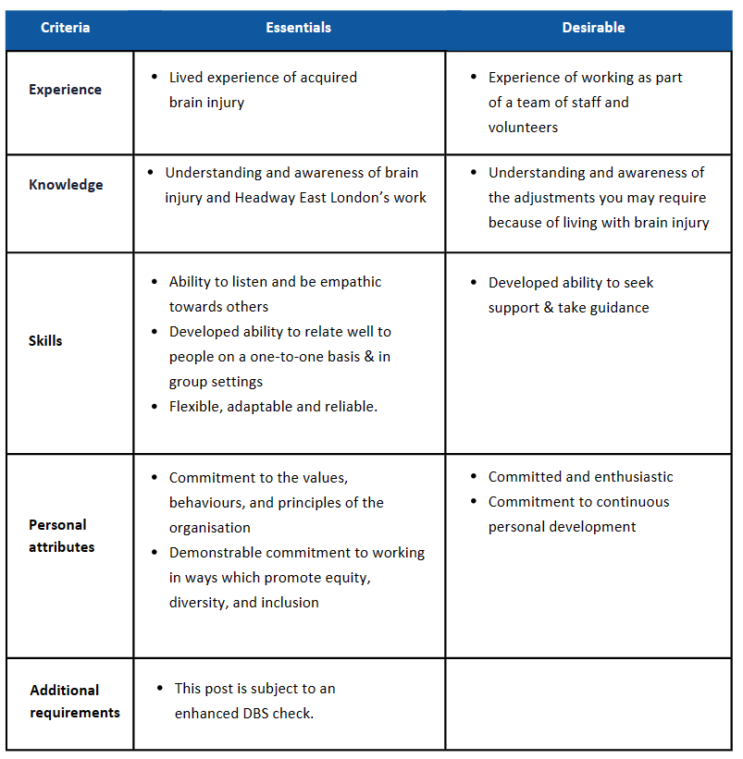

Criteria
Essentials
b

To Apply
Please send us a supporting statement explaining why you would like to work with us in this role in either one of the following formats:

- A written statement in word or pdf format (2 pages maximum) to be sent to recruitment@headwayeastlondon.org.
- A short video or audio (3 minutes maximum), which can be made with your phone and sent via WhatsApp to +44 7510 313050. Please add your name in the text.

Please also send the voluntary Equal Opportunities Monitoring Form (available to download on our website) to our HR team at recruitment@headwayeastlondon.org.

The deadline to apply is Monday 8th April 2024, 9pm.
Interviews will be held on Monday 15th April 2024.

If you have any questions about how to send your statement or if you have any access requirements, please email our HR team at recruitment@headwayeastlondon.org.

For more information about the role and Headway East London, please contact the Casework Manager Paul McKay via email at paul.mckay@headwayeastlondon.org or call 020 7749 7790.
If you find yourself in need of a couple of extra days, please don’t hesitate to contact us to request an extension.

Headway East London is an Equal Opportunities Employer and we are committed to ensuring that all staff are motivated, skilled and rewarded by their work. We welcome applicants regardless of race, religion or belief, colour, national origin, sex, sexual orientation, disability, age and other protected status as required by law. We promote and protect human rights; they are the foundation of what we do.

We want to be an inclusive place where a diverse mix of talented people want to come and contribute their unique strengths and perspectives. We are focused on equality and believe that all the fascinating characteristics that make us different, make us more able to deliver our life-changing work with passion and creativity.

